Order of Worship

Serving God and neighbour
in this community
since 1817

Prelude Sonata for Trumpet Maurizio Cazzati
Entry of Holy Scriptures
Call to Worship
Hymn O God our help in ages past #330
Prayer of Approach & The Lord’s Prayer (inside) Introit Great God, your love has called us here Brian Wren
We come with self-inflicted pains of broken trust and chosen wrong, half- free, half bound by inner chains, by social forces swept along, by powers and systems close confined yet seeking hope for human-kind.

Greetings & Announcements
Stewardship minute John Marshall
Time of Remembrance
In Flanders Fields Ray Quenneville
Presentation of Wreaths Aime Delacretaz
Last Post Larry House
Silence
Lament Kaj Sullivan
Reveille
Hymn O Canada #800
Scripture Reading Acts 16:6-15
Anthem In This Moment of Remembrance Dale Wood
In this moment of remembrance the sacrament is spread; here we celebrate Christ’s presence through the wine and broken bread. At this table of communion in the light shed from above, we are sheltered in his mercy and surrounded by his love.

Sermon ‘The Lord opened her heart’ Acts 16:14
Offertory Diapason Movement John Stanley Doxology Praise God from whom all blessings flow (inside)
Hymn Put peace into each other’s hands #560

The Apostles’ Creed (inside)
Invitation to the Lord’s Table
The Great Prayer of Thanksgiving
Sharing of Bread & Wine
Hymn O day of peace #732 Benediction & Choral Congregational Amen
Postlude Trumpet Voluntary in C Simon Stubley

If you wish to leave during the Postlude, please do so quietly.

WELCOME TO

ST. ANDREW’S
PRESBYTERIAN CHURCH

November 6, 2016

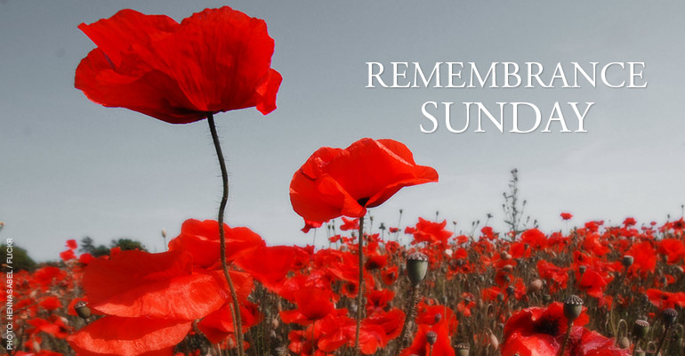

A warm welcome in the name of Jesus Christ and a special welcome to all visitors and friends with us this morning.
Ashley Reynolds is our certified caregiver for the nursery held just off St. Andrew's Hall in the Polson Davis Room. Infants and children aged three and under are welcome.
Laura Tyner-Clement is our church school teacher, whom children are welcome to join immediately after the ‘Time for Children’ during the service.
Please ask one of the ushers for any additional information.

St. Andrew’s Presbyterian Church
130 Clergy Street East, Kingston, ON K7K 3S3
TEL: (613) 546-6316
Office Hours – 9:00 a.m. to noon. Mon-Thurs.
(Use the Clergy St. door, next to the cannon)

Chair of P&M - Peter Trudeau
Clerk of Session – Donna Delacretaz
Director of Music – John Hall
Minister – The Rev. Andrew Johnston
www.StAndrewsKingston.org

The Lord’s Prayer
Our Father who art in heaven,
hallowed be thy name.
Thy kingdom come, thy will be done,
on earth, as it is in heaven.
Give us this day our daily bread,
and forgive us our debts,
as we forgive our debtors.
And lead us not into temptation,
but deliver us from evil.
For thine is the kingdom,
the power, and the glory, forever. Amen

Scripture Reading
Acts 16:6-15
They went through the region of Phrygia and Galatia, having been forbidden by the Holy Spirit to speak the word in Asia. When they had come opposite Mysia, they attempted to go into Bithynia, but the Spirit of Jesus did not allow them; so, passing by Mysia, they went down to Troas. During the night Paul had a vision: there stood a man of Macedonia pleading with him and saying, ‘Come over to Macedonia and help us.’ When he had seen the vision, we immediately tried to cross over to Macedonia, being convinced that God had called us to proclaim the good news to them.
We set sail from Troas and took a straight course to Samothrace, the following day to Neapolis, and from there to Philippi, which is a leading city of the district of Macedonia and a Roman colony. We remained in this city for some days. On the Sabbath day we went outside the gate by the river, where we supposed there was a place of prayer; and we sat down and spoke to the women who had gathered there. A certain woman named Lydia, a worshipper of God, was listening to us; she was from the city of Thyatira and a dealer in purple cloth. The Lord opened her heart to listen eagerly to what was said by Paul. When she and her household were baptized, she urged us, saying, ‘If you have judged me to be faithful to the Lord, come and stay at my home.’ And she prevailed upon us.

Doxology
Praise God, from whom all blessings flow;
Praise God, all creatures here below;
Praise God above, ye heavenly host;
Praise Father, Son, and Holy Ghost. Amen.

Apostles’ Creed
I believe in God, the Father Almighty,
Creator of heaven and earth.

I believe in Jesus Christ,
God’s only Son, our Lord.
who was conceived by the Holy Spirit,
born of the Virgin Mary,
suffered under Pontius Pilate,
was crucified, died, and was buried;
he descended to the dead.
On a third day he rose again;
he ascended into heaven,
he is seated at the right hand of the Father,
and he will come to judge the living and the dead.

I believe in the Holy Spirit,
the holy catholic Church,
the communion of saints,
the forgiveness of sins,
the resurrection of the body,
and the life everlasting. Amen.

Notes from the Director of Music
In today’s service, we are asked to remember. The words of the Anthem by Carleton C. Buck are about remembering the last supper and Christ’s love for us. Today we also remember those who fought and died for our freedom. The Introit uses words from hymn #226 written by the very successful contemporary British hymn writer Brian Wren. The tune for the Introit is from the well-known Navy Hymn, called “Melita” and named after the island of Malta. Acts 28 and 29 describe a shipwreck on this island involving the Apostle Paul. The composer John Bacchus Dykes composed the tune to match the words of William Whiting (Eternal Father, strong to save) and thus gave the tune its title. The tune is often used at funerals and Remembrance Day Services.
Were it not for their enduring music, many composers would have passed from memory. Such is the case with Simon Stubley (1702-1754) who composed the Postlude. His Trumpet Voluntary is probably his most famous piece but little is known about this English organist and composer. There were several composers of his time who were much better known such as Maurice Green, William Boyce, George F. Handel and John Stanley. A little piece by Stanley (1713-1786) is heard at the Offertory. Another little-known composer is remembered mainly for his trumpet sonatas which started a trend for other composers to compose sonatas for trumpet. Maurizio Cassati was born in Italy around 1620 and composed his first Trumpet Sonatas around 1650 when the sonata form was not clearly established-hence there are no slow movements in the sonata which is presented as the Prelude.
Many thanks to Larry House for making our trumpet music possible

Ushers
This morning – The Elders of St. Andrew’s Church
Next Sunday – Bob Hessell, Holly Turnbull,
Rory Warnock, Cheng Shyu
Flowers

The flowers today are in memory of Sergeant John Payne McCormick. “Jackie”, brother of Derek McCormick, was a member of Royal Air Force Squadron 514. Their Lancaster Bomber crashed returning from a mission in Germany in February 1944, killing all crew. Jackie was 19.

Today

Special welcome to visitors this morning. Please stay for a glass of tea, coffee or lemonade in St. Andrew's Hall after the service, and allow us an opportunity to introduce ourselves.

Photodirectory
We are planning to undertake a new photo directory for our 200th anniversary celebrations. Please make a point of stopping in either before or after the service today. And thanks to Changuk and Greg for coordinating!

Presbytery Report on St. Andrew's
Copies of this report are now available in St. A’s Hall.

This Week

St. Andrew’s Autumn Study Series Continues
Tuesday evenings until November 22, 7:00-8:30 pm in St. Andrew’s Hall. In preparation for the 500th anniversary of the Reformation of the Church, join the Minister for a series based on a DVD study produced by Westminster Theological Seminary. Learn about the witness of Luther, Zwingli, Calvin and Knox, & the 5 ‘solas’ of Reformation theology.

The Sound of Bells
Handbell practice continues Wednesdays at 7:30 pm.
Lots of bells in need of an extra pair of hands! Speak to John Hall for information.

Advance Notice

Reception of New Members
Sunday November 20, 10:30 a.m.
Do you feel that this might be a community with whom you would like to grow in Christian worship, fellowship and service? You would be welcome! Speak to one of the Elders or the Minister for details.

First Responders
If you have training that could help us in the case of an emergency, could you please add your name to the St. Andrew's First Responders signup sheet available in St. Andrew's Hall.

Also…

Art Show
The Mess Open Arts Studio invites you to our Annual Art Show and Sale. Showing and sales until December 8th, on Tuesdays–Thursdays from 10 am to 2 pm. Come join us!

Operation Christmas Child
Shoe boxes are again available this year! School supplies, personal items, small gifts, and toys will bring joy and happiness to a child somewhere in the world – often in war-torn and poverty-stricken nations. Through this ministry, the love of Jesus is expressed and these simple shoeboxes DO change lives, families, and villages.
Check the display in St. Andrew’s Hall and pick up one or more boxes to fill. Last year we sent off 55 boxes. Let’s aim for 65 this year as we join others around the world spreading the gospel in this unique way! The boxes are due back next Sunday – Barb Zabel

The Royale
The minister will be conducting a service here Tuesday November 8 at 11 a.m. If you are visiting a friend, come along and support the chorus! Thanks to David Saunders for accompanying on the piano.

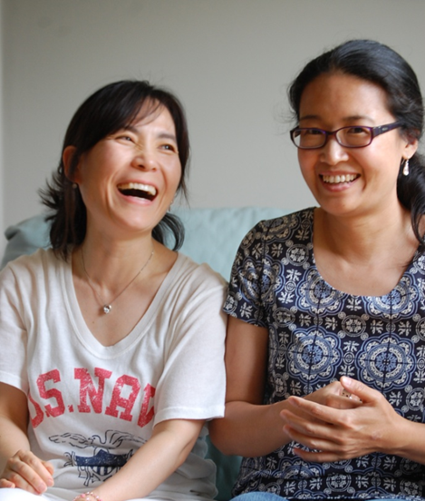
November 6: Sharing God’s Love

Antioch Community Church is a new congregation in Oakville, Ontario. Striving to build a strong foundation in the community, they participate in many programs that reach out to people in need – families who fall below the poverty line, stressed single parents and retirees that struggle to make ends meet.

Members go door to door to collect food for a local food bank and work with Kerr Street Ministries to provide hope to people living in need. A community breakfast for ninety people helped Antioch build relationships while sharing a home-cooked meal. One member was inspired to collect donations for a second community breakfast.

Antioch is a church where people can come together to serve and show God’s compassion, while reaching out in love to the community. This year, St. Andrew’s has committed $20,000 to supporting Presbyterians Sharing to serve communities like Antioch.

Prayer

Give us courage, O Lord,
To stand up and be counted,
To stand up for those
Who cannot stand up for themselves,
To stand up for ourselves
When it is needful for us to do so.

Let us fear nothing
More than we fear you.
Let us fear nothing
More than we love you,
Let us have no other God before you,
Whether nation or party or state or church.
Let us seek no other peace
But the peace which is yours.

And make us your instruments,
Opening our eyes and ears and our hearts,
So that we should know always
What work of peace we may do for you.
For thus we shall fear nothing also.

by Alan Paton
from the Westminster Collection of Christian Prayer

-----------------------------------------------------------------------------------------------------------------
Financial Offerings Update
Budgeted Received
October 30, 2016 $3,855 $3,521
Year to Date $191,498 $163,158

