Epiphany Worship

‘Epiphany comes from the Greek word meaning ‘manifestation’. It is a season in which we celebrate the revelation of God in Jesus to all humanity.

The Embrace of God: Sought After
Sunday January 7, 10:30 a.m.
We hear how God drew those magi of the east to the side of the Christ child (Matthew 2:1-12). We celebrate how God has drawn us to the Risen Christ, and join in Holy Communion.

The Embrace of God: Beloved
Sunday January 14, 10:30 a.m.
We hear how God declared over Jesus at his baptism ‘You are my beloved’ (Luke 3:21-22). We celebrate how God extends that love to us through Christ and our baptism.

The Embrace of God: Forgiven
Sunday January 21, 10:30 a.m.
We hear how God in Jesus forgives the sincerely penitent and opens us to lives of ‘great love’ (Luke 7:36-50). Linger for a congregational pot luck after the service.

Week of Prayer for Christian Unity
Sunday January 28, 10:30 a.m.
It is good to remember that all Christians are members of the one Church of Christ. This morning we welcome the Rev. Stephen Kendall, Principal Clerk of the General Assembly, to share news of the World Communion of Reformed Churches.

And …

Imago Dei
This St. Andrew’s group meets the first Thursday of each month, 4:30-5:30. If you are desiring to know God better and experience a closer walk with God, please join us. Contact Dorothy for more information at dotmessenger@gmail.com

Women’s Missionary Society
Join us in St. Andrew’s Hall Monday, January 15, 1:30pm – 3:00pm as we continue to study and support the Church’s mission. Contact Louise Axford for information at 613-634-5782.

Sunday Perspectives
We continue our monthly film and discussion at the Screening Room on Princess Street – Sunday January 21,
7 p.m. Film T.B.A.

Morning Monthly Bible Study
Join us as we gather with our Minister to join our journey through the letter of James. No prior experience with Bible study needed. Thursday January 25, 10 a.m. at the church.

Advance: Pop-Up Photo Display
On Sunday Feb. 11th, a Valentine’s pop-up exhibit at coffee time. Dust off your photos - of you and your loved one/s (wedding, family, best friend …) Clues okay but no names! We’ll have a guessing good time.

Review

Thanks to Anne-Marie Gabrini and Fern Houston for the series of sanctuary Advent-Christmas-Epiphany banners. Thanks to the Choir of St. Andrew’s and John Hall for a wonderful Advent morning of scripture and music on December 17. Thanks to Lindsay for leading in the Advent candle lightings, and Laura for leading the Time With Children on the morning of December 24. The sanctuary was lit with candles burning on Christmas Eve, and some new lamps illuminated the front of the sanctuary beautifully. On Hogmanay, the Elders offered mid-morning coffee and muffins before worship in a packed St. Andrew’s Hall.
Thanks be to God.

Fifty Five boxes were contributed to Samaritan’s Purse ‘Operation Christmas Child’. For the mothers and their children who will seek shelter over the coming year at Interval House, over $550 was contributed on White Gift Sunday to provide subscriptions of magazines and other amenities. Christmas Eve offerings to Special Meals and international relief amounted to over $950. In addition to our 2017 commitment to Presbyterians Sharing of $25,000, designated offerings of over another $17,000 supported eleven initiatives from HomeBaseHousing and Queen’s Inter-Varsity Fellowship to Saskatoon Native Circle Ministry and Reformed Church schools in the Ukraine. Thanks be to God.
Investing in the Future of our
Partner Churches

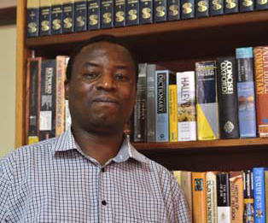

In 2011, with support from Presbyterians Sharing, the Rev. Takuze Chitsulo (the Church of Central Africa (Presbyterian in Malawi) began to study at the University of Kwazulu-Natal in South Africa.
In 2016, Takuze graduated with a Doctor of Philosophy in Biblical Studies and one year later, he was appointed as the new Principal of Zomba Theological College in Blantyre, Malawi. The Rev. Dr. Chitsulo sees his appointment as an opportunity to give back to the Malawian community.
In thanking the PCC, he said “You didn’t only educate me, but you taught the whole church in Malawi.”

Leadership Development grants are an
investment in the future.

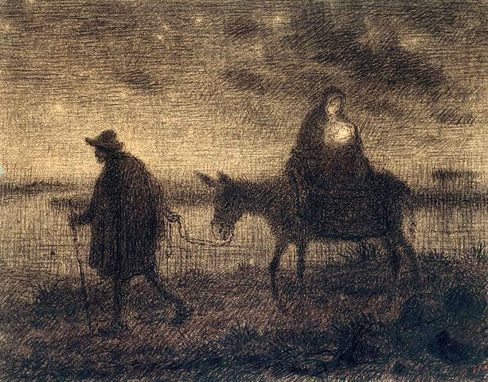

Get up, take the young child and his mother, and flee’ (Matt. 2:13)

Holy God, we pray for all those who are far away from home
– Hold them in your love.

That those sick in home and hospital may know their value as whole people, mind, body and spirit – Hold them in your love.

That those who seek refuge from violence, oppression and injustice may know that hatred does not have the last word
– Hold them in your love.

That those who seek their home in your heart may know that they are cherished and beloved
– Hold them in your love.

And for ourselves we pray.
Lord God, by the love we have seen in Jesus, hold us, nurture us and sustain us, that in your name we may draw others to you. Amen. Mary Cotes
From the Desk of the Minister, 2018

The Days
of January

St. Andrew’s Church
The Presbyterian Church in Canada

Every Sunday morning 10:30 a.m.
with a nursery for infants
and a programme for children

Join us!

Princess at Clergy Streets,
Kingston Ontario K7K 3S3
613-546-6316
www.standrewskingston.org

